|  |  |
| --- | --- |
| **cloudenabled** | |
| **Author** | **Sushil Kumar** |
| **Documentation Version** | **V1.0** |

**Pivotal Cloud Foundry-Developer**

**Pivotal Cloud Foundry Developer - Push to the Cloud**

#### Table of Contents

* [Requirements](https://content.enablement.pivotal.io/pivotal-cloud-foundry-developer/cf-push-to-the-cloud/index.html#requirements:d680e8a854a7cbad6d490c445cba2eba)
* [What you will learn](https://content.enablement.pivotal.io/pivotal-cloud-foundry-developer/cf-push-to-the-cloud/index.html#what-you-will-learn:d680e8a854a7cbad6d490c445cba2eba)
* [Exercises](https://content.enablement.pivotal.io/pivotal-cloud-foundry-developer/cf-push-to-the-cloud/index.html#exercises:d680e8a854a7cbad6d490c445cba2eba)
  + [Download the cf CLI](https://content.enablement.pivotal.io/pivotal-cloud-foundry-developer/cf-push-to-the-cloud/index.html#download-the-cf-cli:d680e8a854a7cbad6d490c445cba2eba)
  + [Login to Pivotal Cloud Foundry with the cf CLI](https://content.enablement.pivotal.io/pivotal-cloud-foundry-developer/cf-push-to-the-cloud/index.html#login-to-pivotal-cloud-foundry-with-the-cf-cli:d680e8a854a7cbad6d490c445cba2eba)
  + [Pushing apps](https://content.enablement.pivotal.io/pivotal-cloud-foundry-developer/cf-push-to-the-cloud/index.html#pushing-apps:d680e8a854a7cbad6d490c445cba2eba)
    - [Questions](https://content.enablement.pivotal.io/pivotal-cloud-foundry-developer/cf-push-to-the-cloud/index.html#questions:d680e8a854a7cbad6d490c445cba2eba)
  + [Explore Apps Manager](https://content.enablement.pivotal.io/pivotal-cloud-foundry-developer/cf-push-to-the-cloud/index.html#explore-apps-manager:d680e8a854a7cbad6d490c445cba2eba)
  + [Clean up](https://content.enablement.pivotal.io/pivotal-cloud-foundry-developer/cf-push-to-the-cloud/index.html#clean-up:d680e8a854a7cbad6d490c445cba2eba)
* [Beyond the class](https://content.enablement.pivotal.io/pivotal-cloud-foundry-developer/cf-push-to-the-cloud/index.html#beyond-the-class:d680e8a854a7cbad6d490c445cba2eba)

# Requirements

[Lab Requirements](https://content.enablement.pivotal.io/pivotal-cloud-foundry-developer/requirements) : Follow requirement section of the session

# What you will learn

* How to access Apps Manager
* How to install the cf CLI
* How to target a Pivotal Cloud Foundry instance with the cf CLI
* How to cf push apps

# Exercises

## Download the cf CLI

Using [Pivotal Web Services](http://run.pivotal.io/) you can login to Apps Manager [here](http://run.pivotal.io/).

1) [Review the Apps Manager Documentation](http://docs.pivotal.io/pivotalcf/console/dev-console.html). Knowing where to go for help is essential.

2) Upon logging into Apps Manager for the first time you will be greeted with a welcome message that will walk you through the installation of the cf CLI.

If you do not see this dialog, the same information can be found under Tools (Left side).

3) Download and [install](http://docs.pivotal.io/pivotalcf/cf-cli/install-go-cli.html) the cf CLI for your platform.

4) Open a terminal window. Explore the cf CLI. In the terminal window type cf. Review the commands available with the cfCLI. Help on a specific command can be found using the --help option (e.g. cf login --help).

$ cf

...

$ cf login --help

## Login to Pivotal Cloud Foundry with the cf CLI

1) Continue to follow directions for logging in with the cf CLI. You can copy and paste the cf login command directly from Apps Manager.

$ cf login -a <substitute the API endpoint from Apps Manager>

2) Review your current API endpoint, user, org, and space

$ cf target

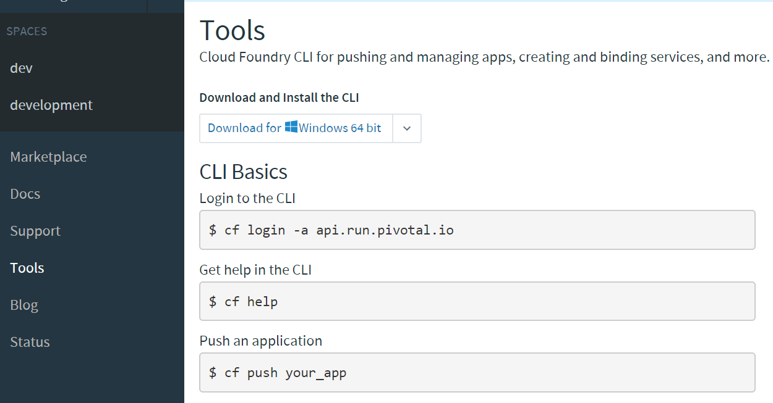

**What Just Happened?**

You have logged into Pivotal Cloud Foundry from two different clients (Apps Manager and the cf CLI). You have installed the cf CLI and targeted a Pivotal Cloud Foundry instance. You are ready to push apps.

## Pushing apps

Next we will push (deploy) several applications.

1) Download the [demo applications](https://content.enablement.pivotal.io/pivotal-cloud-foundry-developer/resources/demo-apps/demo-apps.zip). Copy the file to folder: ~/pivotal-cloud-foundry-developer-workshop (~ is shorthand for the home directory in Linux, Mac and Unix based operating systems). You will need to create this directory in your [home](https://en.wikipedia.org/wiki/Home_directory) directory.

2) Extract the zip file to ~/pivotal-cloud-foundry-developer-workshop/demo-apps.

The zip file contains four directories; each directory contains an application developed in a different language.

3) Open a terminal window and push the node application

$ cd ~/pivotal-cloud-foundry-developer-workshop/demo-apps/node

$ cf push node --random-route -m 128M

4) View the node application in your browser or use curl. The url can be obtained from the cf push output or by issuing the command cf apps.

Example:

$ curl node-northeasterly-zygoma.cfapps.io

Hello Node

5) Repeat steps 3 - 4 for the php, python, and ruby applications.

**NOTE:** Make sure you cd into each directory before pushing.

**What Just Happened?**

You just deployed four applications each based on a different language and runtime. Pivotal Cloud Foundry is a polyglot platform, meaning it supports multiple languages and does so in a pluggable way (via buildpacks)!

## Explore Apps Manager

1) Review the following views:

* Org
* Space
* App

**What Just Happened?**

You have interfaced with Pivotal Cloud Foudry from two separate clients (cf and Apps Manager). Many of the operations that are available in cf CLI are also available in Apps Manager.

## Clean up

1) Delete the applications you just pushed.

This is very important for resource constrained environments.

$ cf **delete** node

Repeat for php, python, and ruby applications.